

THE SUCCESS STORIES FOR THE IMPACT OF MANAPACK FOOD SUPPORT ON CHILDREN.

- The story of Haggai of Severe Malnutrition and High Viral Load
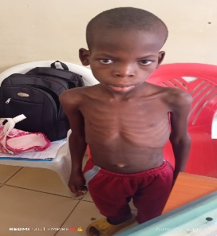
Haggai is a 12 years old boy living with HIV and is on ART at Bwaila facility due to high viral load of 629,425 copies as of 7th August, 2025. In addition, mid-upper arm circumference (MUAC) measurements indicated 12.5cm with a weight of 18 kilograms due to malnutrition. The child stays with his grandmother since his mother died last year and his father married another woman and does not support him.
During the enrollment day, Hagai and his grandmother were called for a case conference to understand his situation. During the case conference, his grandmother narrated that the child was sometimes skipping his drugs due to lack of food at the household since the grandmother depends on casual labor which sometimes can spend somedays without working.
Figure 1: The Status of the Child during Enrollment in nutrition program
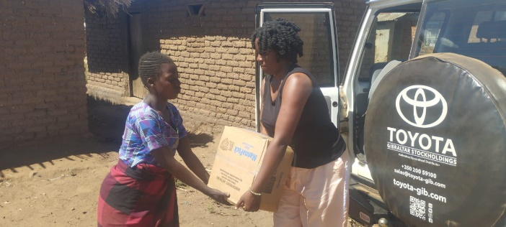
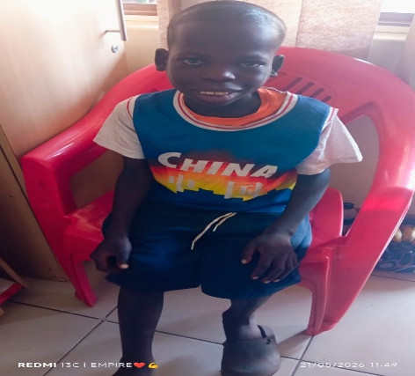
Alliance for Children Everywhere (ACE) in partnership with Lilongwe Catholic Health Commission (LLCHC) supported the child and the household with 2 cartons of Manna packs and 1 carton of potato D as an emergency food support. Further, ACE and LLCHC Social workers intensified weekly home visits for adherence counselling (PSS), reminders of drug refill and uptake, ART education and viral load measurements. The follow-up viral load measurement was done on 25th April, 2026 and the results came out slightly higher than before which read 3,250,000 copies but he has gained some weight. Currently, he is weighing 23.4kgs and his MUAC measurement is at 13.5cm as of 21st May 2026.

Figure 2: Haggai in May, 2026

Figure 3: Distribution of Manna Packs

- The Story of Jimmy Saulosi: HIV Positive Adolescent on TB Treatment and Undernourished.
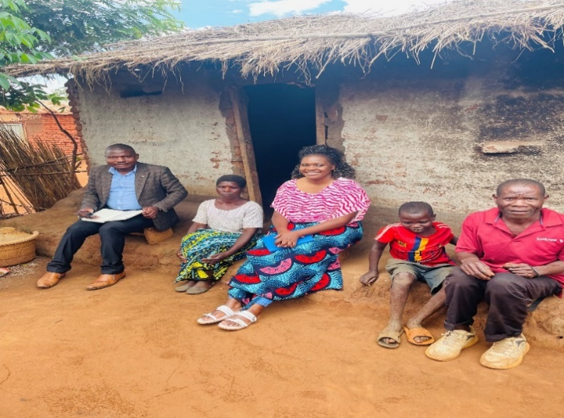
Jimmy Saulosi is a 14-year-old boy receiving HIV treatment at Nthondo health facility after being identified with a high viral load of 52,637 copies/ml. The viral load results were shared with his caregiver on 18 August 2025.Jimmy’s mother is HIV positive, while his father has repeatedly tested HIV negative despite undergoing several HIV tests. In addition to HIV treatment, Jimmy is also receiving TB treatment and was diagnosed with a skin infection. At the time of enrolment into ART treatment program, he was undernourished due to food insecurity within the household. Several factors contributed to Jimmy’s unsuppressed viral load. He frequently missed ART doses because medication administration had been entrusted to his 9-year-old brother, and at times Jimmy would throw away the medication instead of taking it. He also missed ART clinic appointments because his caregiver was unwell and unable to accompany him to the health facility. Food insecurity further affected adherence, as Jimmy reported experiencing dizziness whenever he took medication on an empty stomach. In addition, the pill burden became a challenge because he was taking both ART and TB medication, amounting to nearly seven tablets per day during his four-month TB treatment period. Following assessment, several action points were agreed upon to improve Jimmy’s adherence and overall wellbeing. These included conducting bi-weekly home visits to strengthen ART adherence counselling, intensifying WASH services within the household, and referring the family for a mosquito net at Nthondo Health Centre.
Figure 1: Case Conference at Household Level
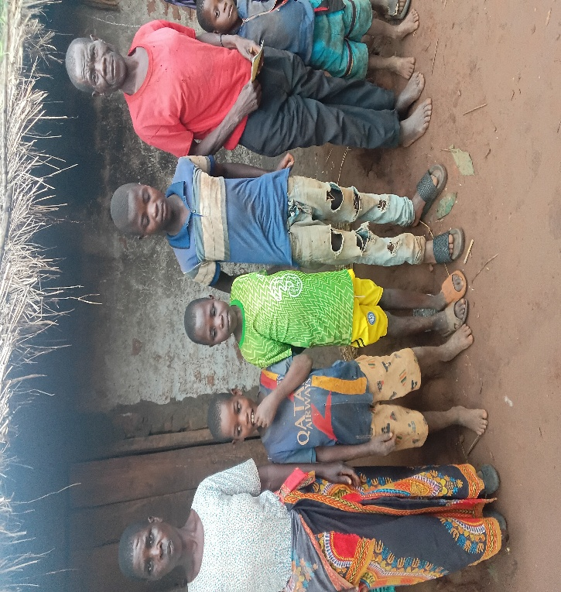
A number of interventions were subsequently implemented to support Jimmy and his family. We supported him and the family with Mana packs (nutritious rice) to improve household nutrition and support treatment adherence. Furthermore, emergency Poteto-D was provided on 10 March 2026 to address the ongoing food insecurity challenges. Through LLCHC, the family also received transport support on 1 April 2026 to facilitate access to healthcare services and clinic appointments. In addition, frequent household visits and follow-up case conferences have continuously been conducted to monitor adherence, provide psychosocial support (PSS), and assess progress. Jimmy also received a mosquito net as part of the agreed interventions through the Health Facility. Although a follow-up viral load sample had initially been collected on 1 April 2026, pending the results, however, there is significant improvements, improved adherences. This provides hope for improved health outcomes and viral suppression for Jimmy.

- The Story of Triumphs of Resilience and Hope
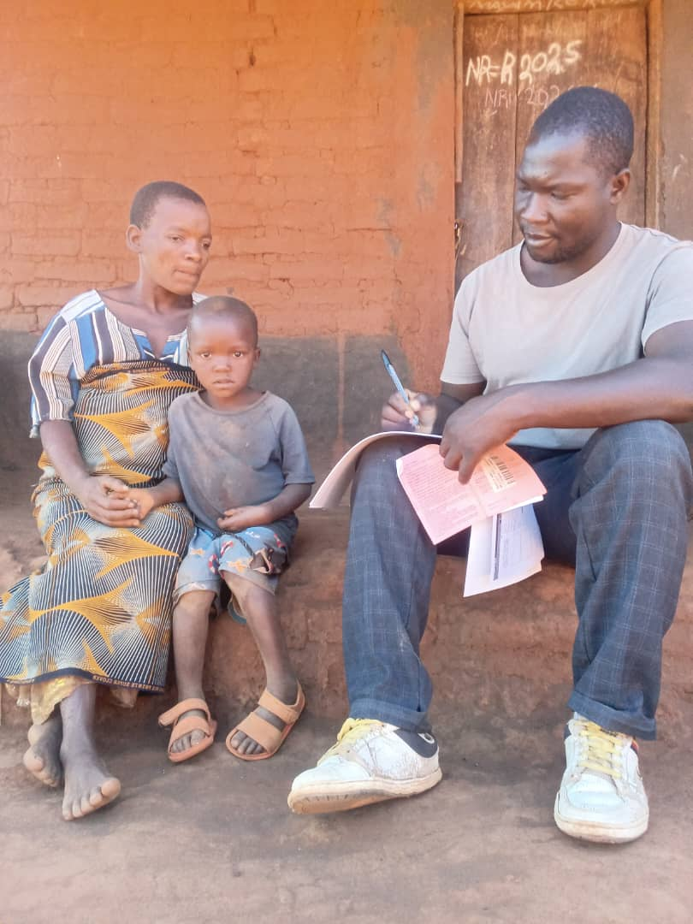
Despite various interventions and commendable progress in identifying children living with HIV, initiate them on treatment, and ensuring continuity of care remain major challenges among the children. This was the case of a 4-year old child; Owen Bondo from Mbets village, Traditional Authority Chiseka in Lilongwe district. The child was born on 23rd June, 2021 and was diagnosed with HIV, 3 months later in September, 2021 and was initiated on Art. He was enrolled into ART Treatment program on December, 2024 since he had high viral load of 911,000 copies and subsequent viral load result in January, 2025 also indicated unsuppressed viral load of 260,625 copies. Adding to this, he had also issues with his developmental milestones since he was stunted with frequent severe illness. This was also compounded with lack of proper care and food as well since his mother had mental issues and could not manage to get medication at Mitundu Community hospital.
Picture 1: Case worker conducting bi-weekly visits for CLHIV with High Viral Load

A joint case conference was convened with ACE Organization, ANAPA organization, Lilongwe Catholic Health Commission, Lighthouse and Ministry of Health staff and the father of the child to review the case. The main drivers of unsuppressed viral load from the case conference were poor ART adherence. This was due to food insecurity at the household and the caregiver was not giving the child drugs when he did not take food. From the case conferences findings, ACE supported the household with emergency food support comprising of Manna packs made of rice and Poteto D. Further, the caregiver was linked to Intensive Adherence Counselling (IAC) sessions by Lighthouse for ART literacy, adherence support and growth monitoring for the child while
After slightly over 2 months of proper nutritious food (Mana pack) and drug uptake, adherence support, the child suppressed his viral load from 260,625 copies to <30 copies. Through Manapack support from USA and joint PSS support from ACE and Catholic Health Commission, the child has achieved positive health outcomes.

- The story of Francis Banni
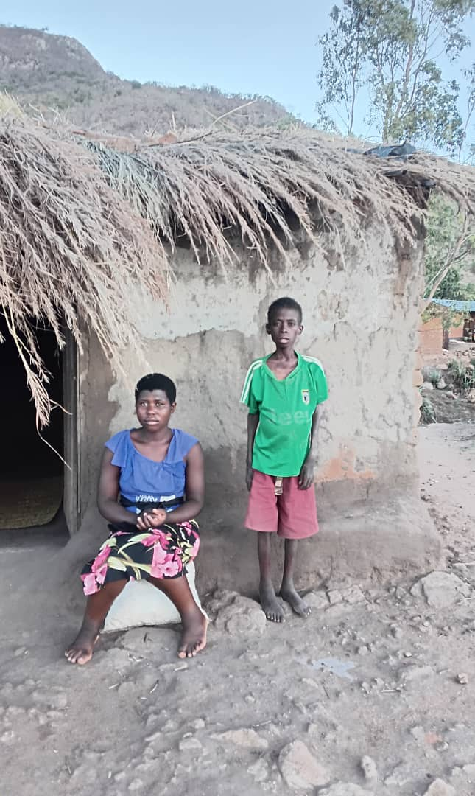
Francis Banni is a 15-year old malnourished CLHIV born on 01/07/2010. He comes from Dede village, GVH Dede, TA Mazengera. He is an orphan from a young age and stays with his sister, Linda Banni, aged 21, who has daughter, but not married. Francis had been receiving ART at Diamphwe and in one of the facility meetings with partners, ACE and LLCHC requested that Francis should receive social services and be visited by Social Workers for PSS service. At that time, the referral was not yet extended to Diamphwe Health facility. So when LLCHC visited the child, it was found that he was in a very critical state of health, with a VL of 12,450. ACE and LLCHC jointly made a referral to Nkhoma Hospital to be assessed for malnutrition where all the tests came out positive. Consequently, he was given therapeutic food like Poteto-D, that’s the flour for instant porridge and 2 cartons of Manapack rice. The hospital provided him with chiponde and they also changed the ART regimen from 13 A to 15 PP. On 12/12/2025. Now, the Viral Load testing comes with very positive change to 219 from 12,450.
Francis Bani at the time of ART enrolment program

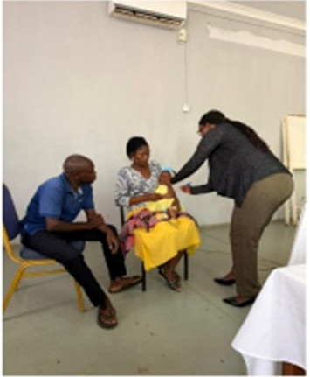
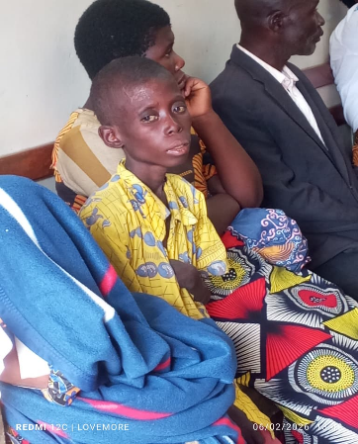
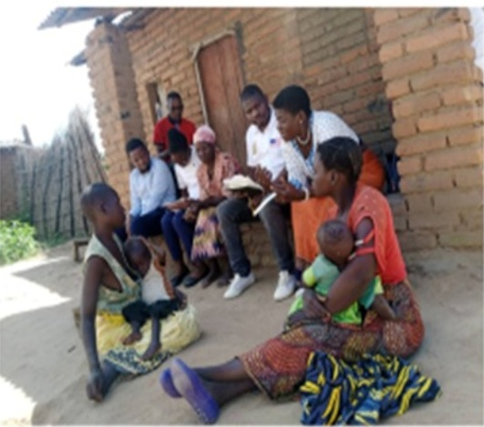
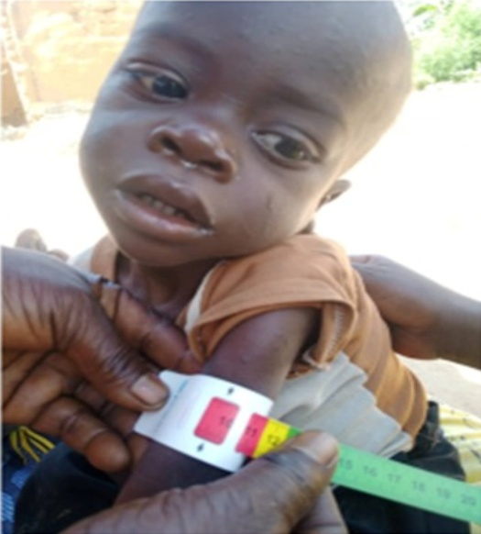

Other program pictures showing the hospital interventions and also Household visit for nutrition education

The Story of Shyreen Steven an orphan
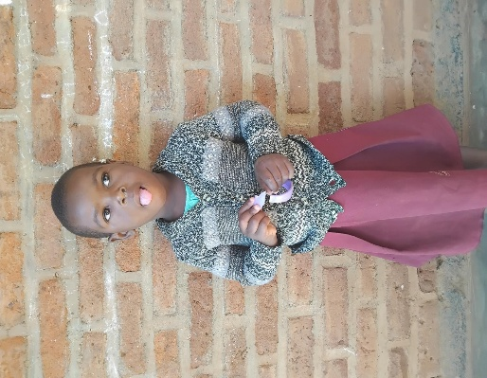
Shyreen Steven, a 5-year-old girl from Kandiwo Village in T/A Kapeni, Blantyre District, faced severe malnutrition due to orphan hood and lack of proper care. She was weak, underweight, and often ill, putting her life at risk. Through the support of Aquaid Lifeline Malawi, the child care institution (CCI), Shyreen was admitted into care and benefited from nutritional (Mana pack food) and emotional support. Supplementary feeding with MannaPack, donated by Alliance for Children Everywhere, greatly improved her health and wellbeing. Today, Shyreen is healthy, active, and cheerful. She now enjoys playing with other children and growing up in a safe and caring environment. Her story is a powerful example of how compassionate care and nutritional support can transform the lives of vulnerable children.

The Story of Isha Zakaliya from a single mother’s family
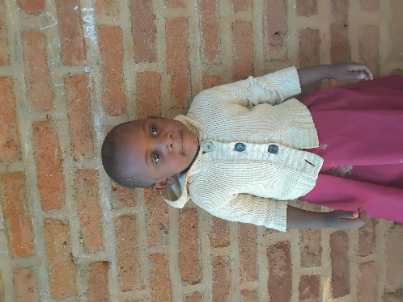
At only 4 years old, Isha Zakaliya from Chiwele Village under T/A Machinjiri in Blantyre District was fighting for survival. Growing up in extreme poverty under the care of a struggling single mother, Isha became severely malnourished and dangerously weak. Her small body lacked the nutrition needed for healthy growth and she was constantly vulnerable to illness. Hope came when Aquaid Lifeline Malawi admitted her into care and began providing nutritional rehabilitation for 90 days (three months consecutively) through the MannaPack supplementary feeding from ACE. The moment Isha started receiving nutritious meals, her health wellbeing completely and positively changed. With continued feeding, medical care, and emotional support, Isha has regained her strength and became very energetic child.

- The story of Dorothy Mavito from a single mother’s family
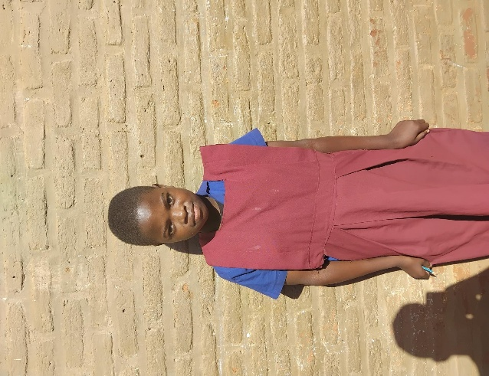
窗体顶端
When Dorothy Maviyo arrived at Aquaid Lifeline Malawi, the effects of hunger and malnutrition were clearly visible. At just 12 years old, the young girl from Fred 1 Village under T/A Kapeni in Blantyre District had become extremely weak and underweight after growing up without adequate food and care. Her single mother, overwhelmed by poverty, struggled daily to provide even the most basic needs for her daughter. Dorothy’s condition was heartbreaking. She lacked the energy to enjoy childhood and was constantly at risk of illness because her body was not receiving the nutrition it needed. To save her life and restore her health, she was immediately enrolled in a supplementary feeding program using MannaPack meals donated by Alliance for Children Everywhere.
Day by day, the nutritious MannaPack meals began rebuilding Dorothy’s strength. What once seemed impossible slowly became reality as she gained weight, recovered her energy, and started smiling again. With medical attention, counselling, and loving support from caregivers, Dorothy transformed from a weak and hopeless child into a confident and cheerful young girl. Today, Dorothy is healthy, active, and full of dreams for her future. Her recovery shows the life-changing impact of MannaPack nutrition support. What began as a fight against severe malnutrition became a story of healing, renewed hope, and a brighter future for a vulnerable child.

- Smiles faces with Manapack in children corners in T/A Kalolo, Lilongwe
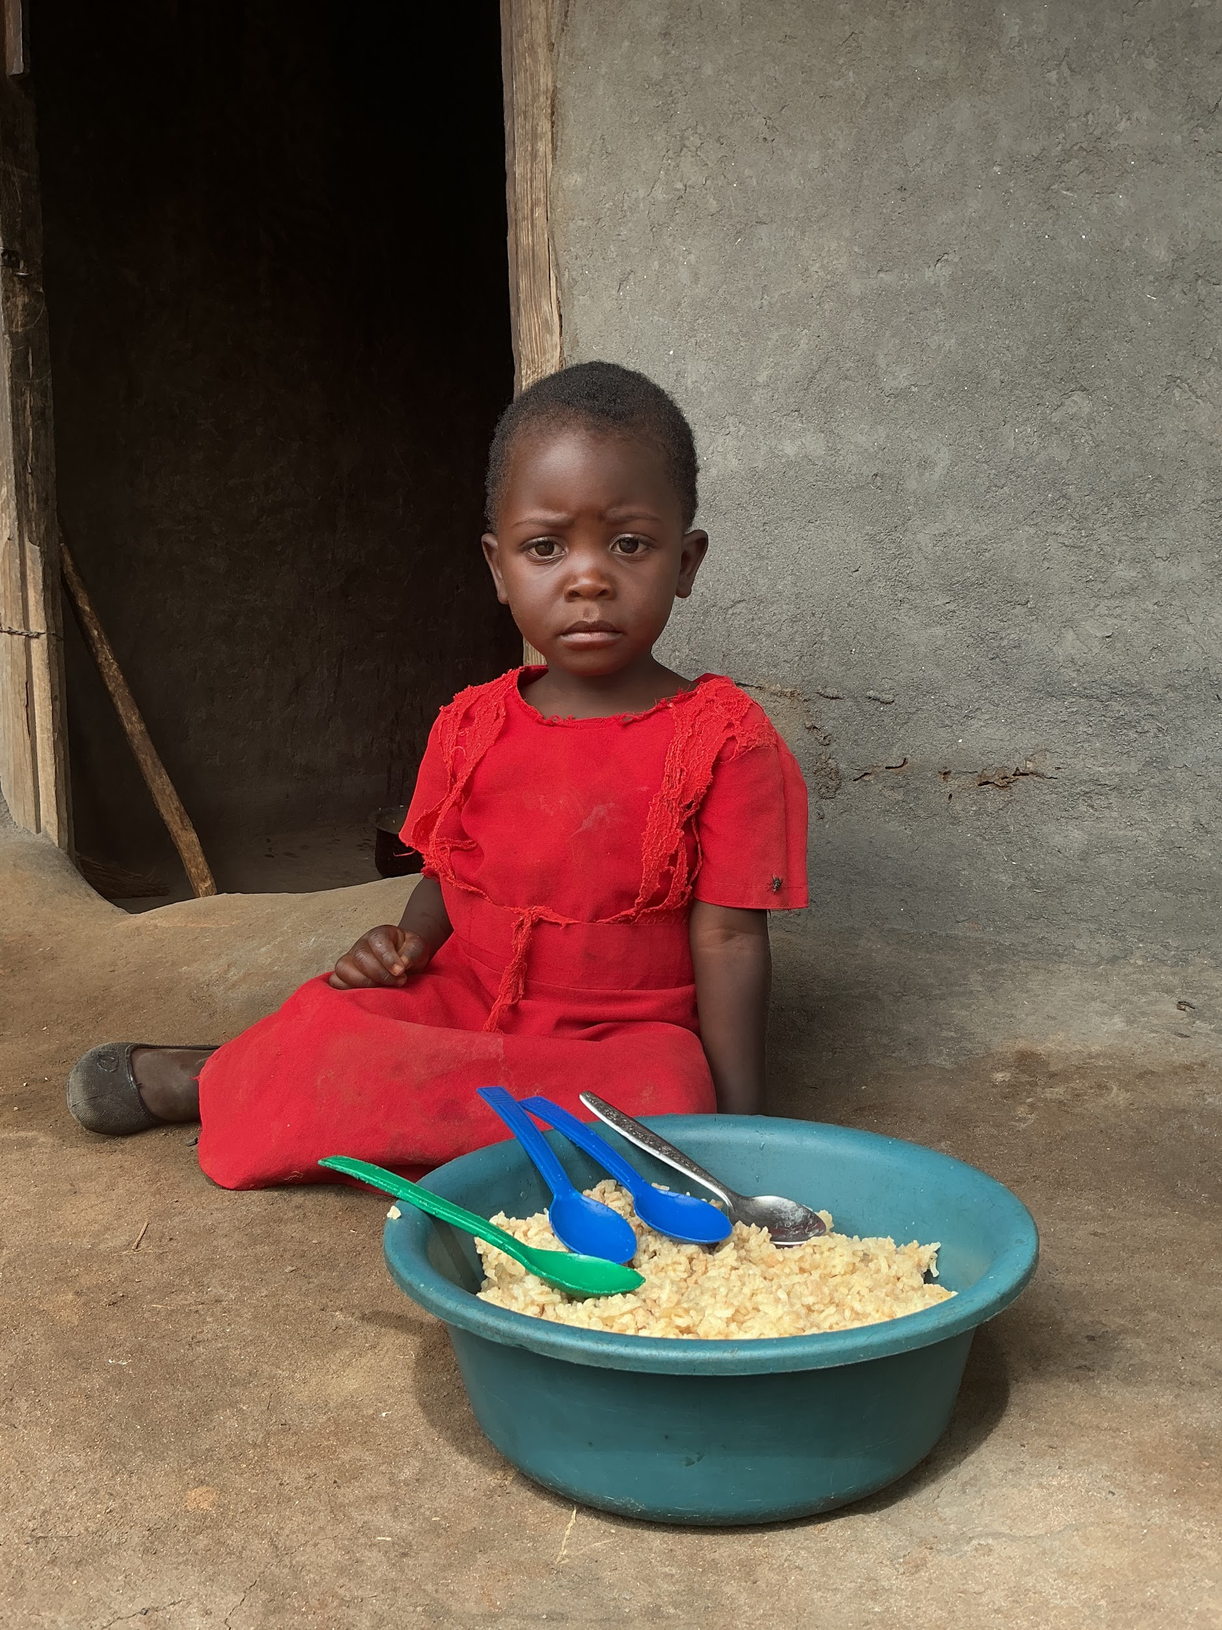
Under the Economic Strengthening and Sustainable Livelihoods Pillar, ACE Malawi, through Children’s Corner activities in all ten children corners became a lifeline of hope for vulnerable children and families living in deep hardship. For many caregivers, every day is a painful struggle to find food and meet the basic needs of their children. However, through the distribution of Manna Packs, ACE not only provided food support but also restored dignity, comfort and hope to families who had silently endured hunger and uncertainty for so long.

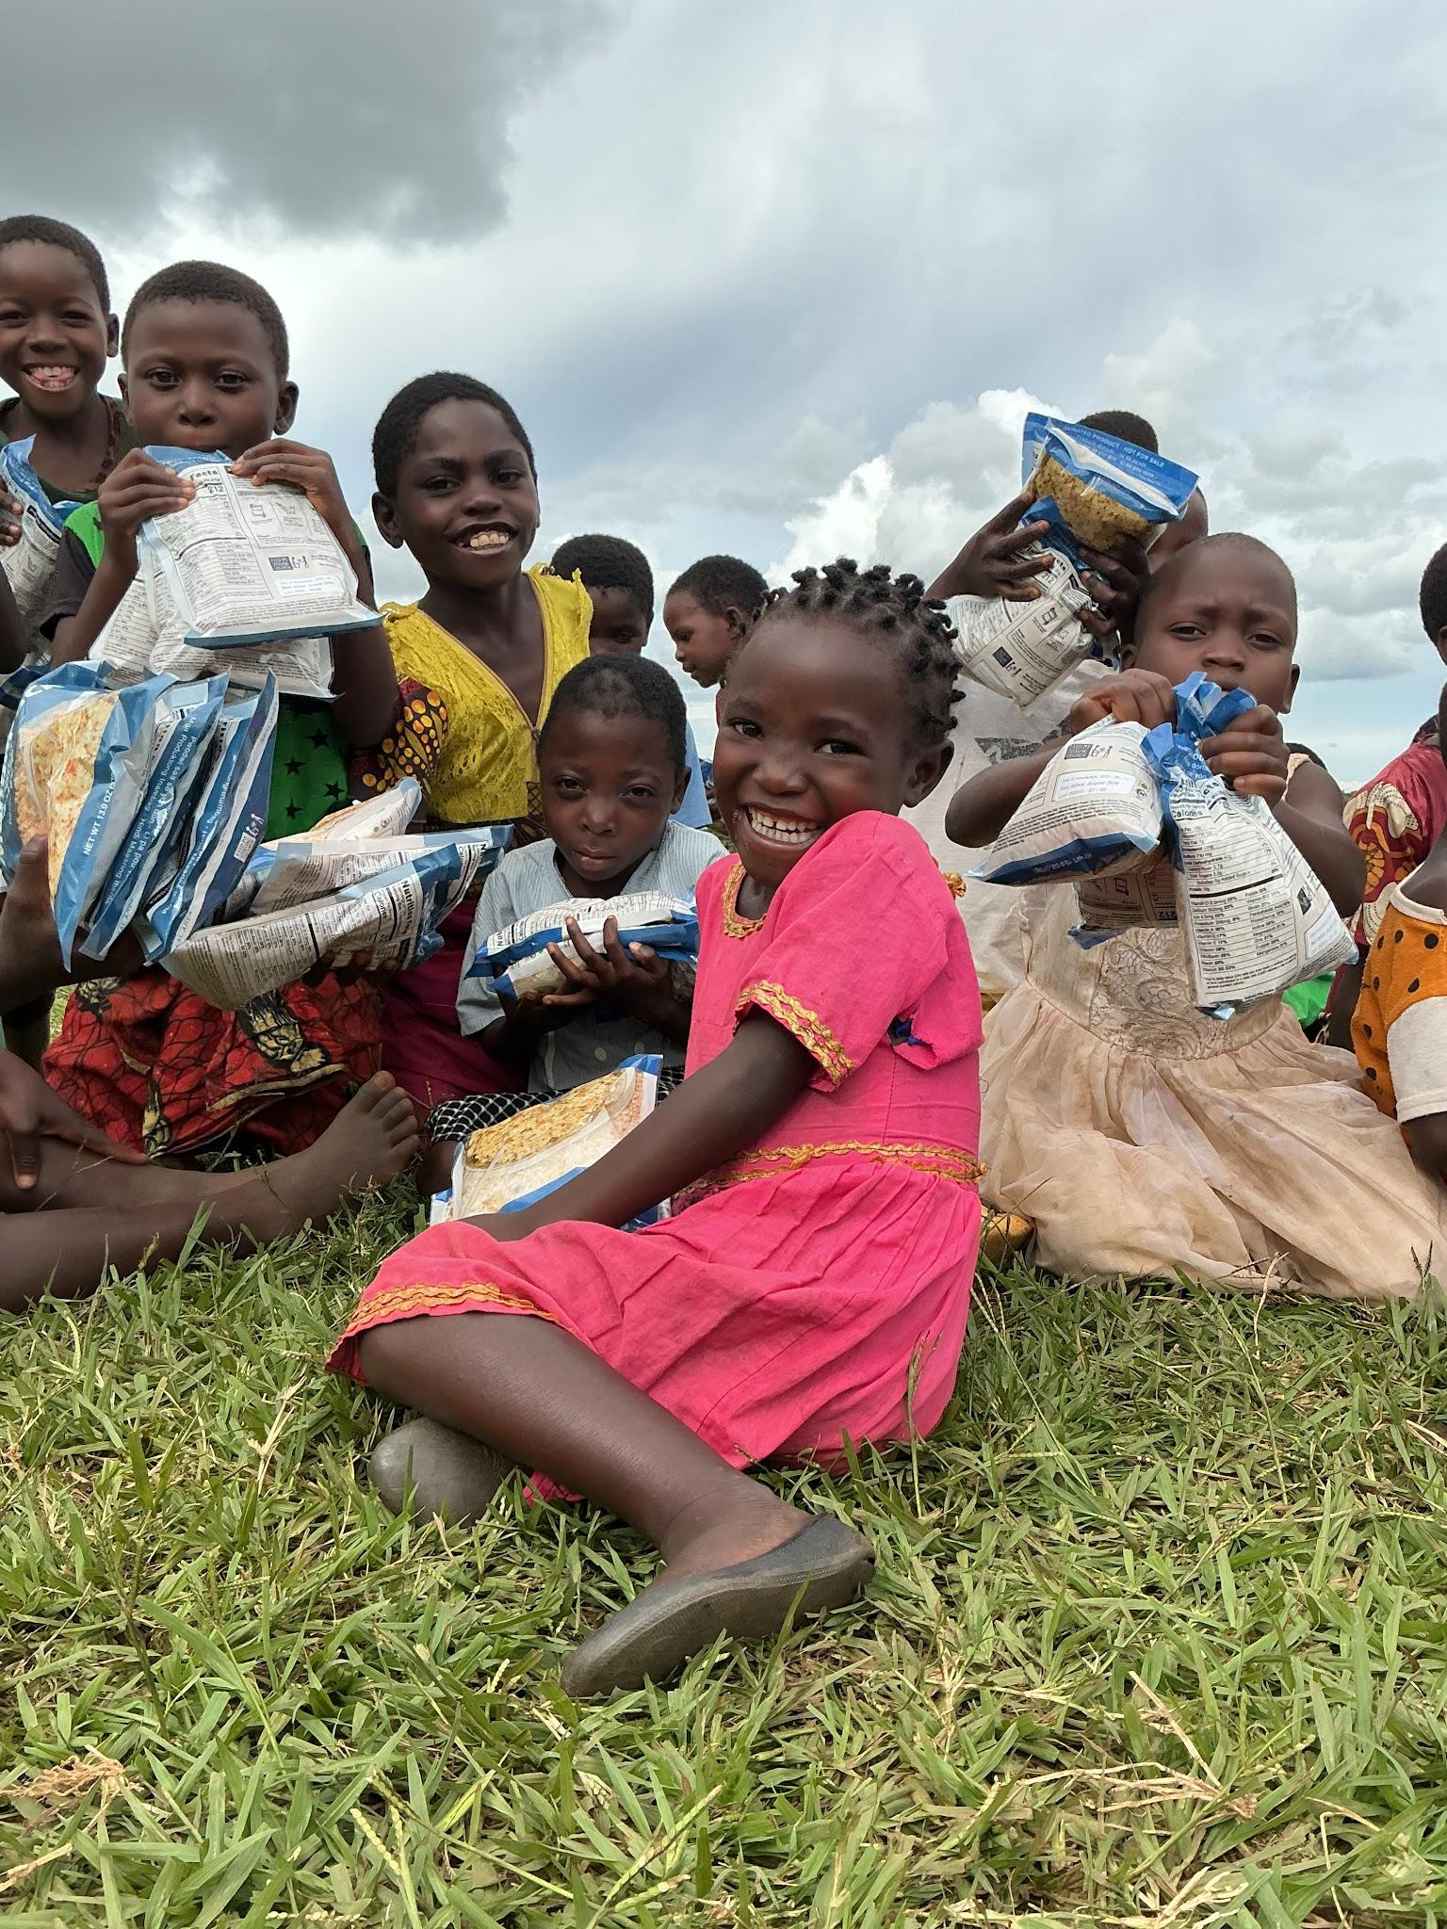
The smiles seen on children’s faces during the activities were more than moments of happiness; they reflected relief, love and the feeling of being cared for and remembered. For many children, the Children’s Corners have become safe places where they can laugh again, feel valued, and experience the warmth of a supportive community. Today, the renewed strength among caregivers and the joy returning into the lives of children stand as an emotional testimony that even the smallest act of care brings healing, hope, and transformation to an entire family.

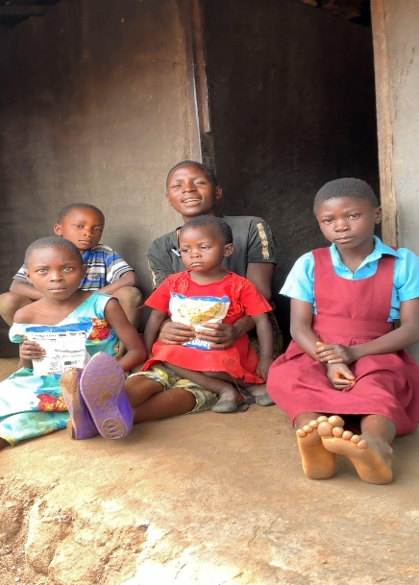
The Story of Enelesi Pondan on her journey towards Stability
The picture is showing Enelesi with her children at her house. She is a vulnerable single mother from Kabwana Village in Lilongwe, faced daily struggles to provide food and care for her four children through her small mandasi business. With most of her earnings spent on basic meals, it was difficult for her to grow her business or save for the future. Through the food support program (Manna Pack distribution) implemented by ACE Organization from USA at Kabwana Children Corner, Enelesi received three cartons of nutritious Manna Pack food support. This has been timely assist easing her burden of feeding her family children and gave her the opportunity to invest more income into her business and savings through the Village Savings and Loans group (VSLA) in the community. Because of the food support, her children started attending school every day instead of missing classes frequently.

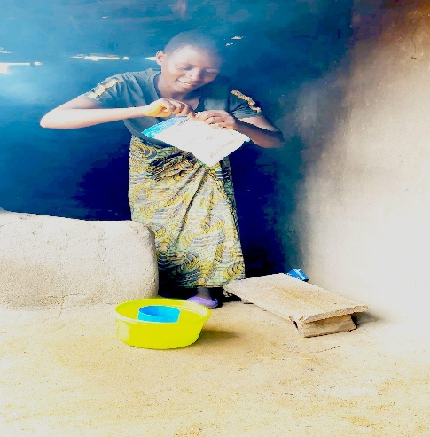
Today, Enelesi’s business is growing, her savings are improving and her children now have more reliable access to nutritious meals. Manapack support has positively supported her family. This has empowered and restored her hope to have a stabile family even though she is divorced.

- Disability is not inability. The story of Letina Finiasi
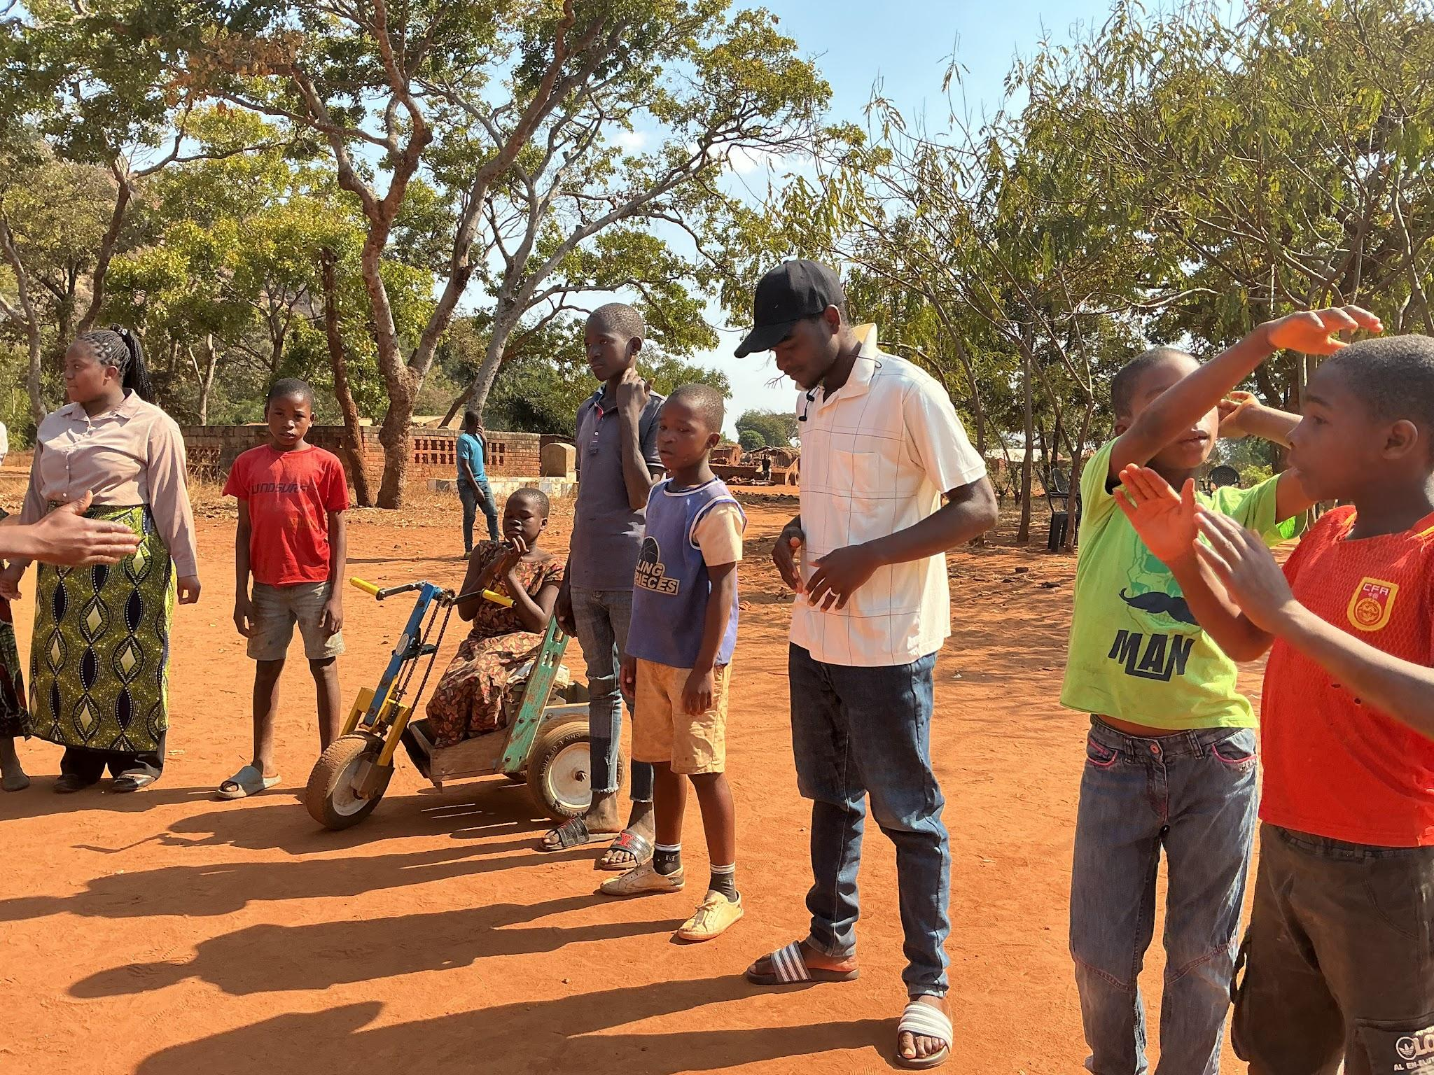
A 12 years old Letina Finiasi from Mkanda Village in T/A Kalolo is a touching example of resilience and hope through the ACE Mana pack’s nutrition support program from USA. Letina, Living with a physical disability, she was left in the care of her grandmother after her parents divorced and remarried. Both her stepparents to the mother and father’s sides refused to take responsibility for her upbringing. Feeling rejected, emotionally broken, and without any food support, she dropped out of school and lost hope in her future due extream hunger and poverty on her life. However, through her active participation in ACE mind skills program at Chawa Children’s Corner, Letina found a safe space where she felt valued, heard and supported. ACE supported her with two cartons of Mana pack rice and one carton of Poteto-D. Her commitment and courage to open up about her pain led to counseling and family interventions by ACE Organization to help restoring hope in her life. Today, Letina has returned to school and continues participating in the mind skills sessions with renewed confidence, proving that love, care and having food support support can help even the most vulnerable child rise again and rebuild their future. Therefore disability is not inability.

- Children Corners brings hope to the hopeless

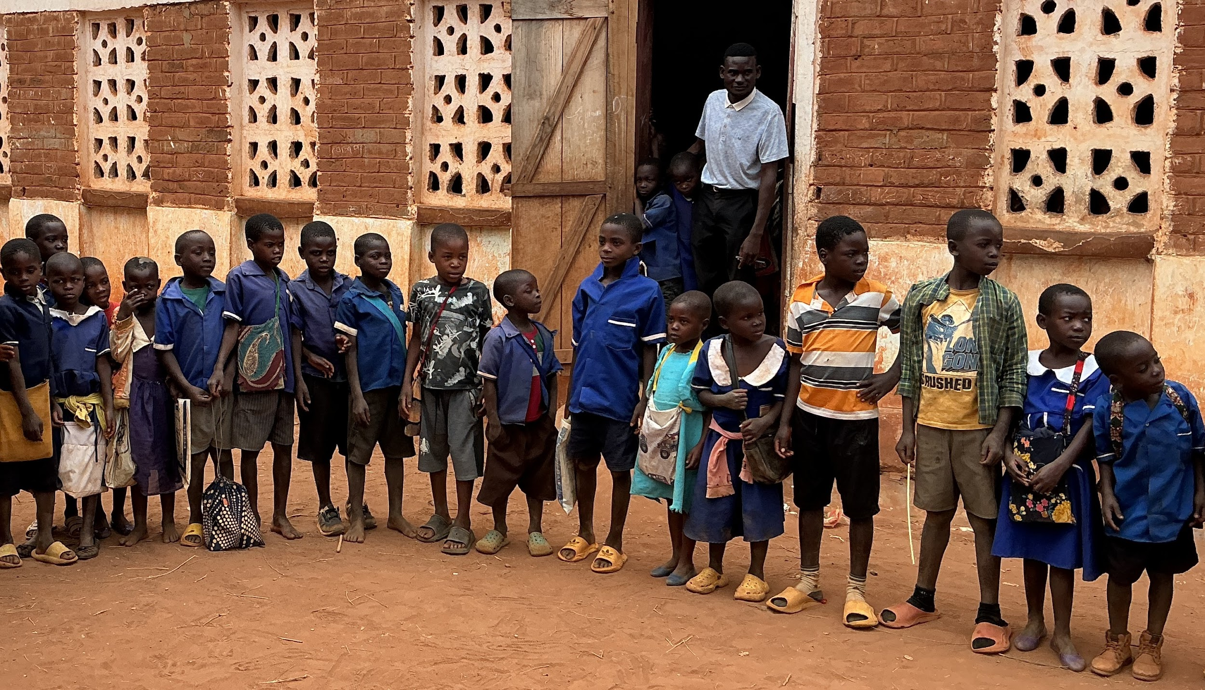
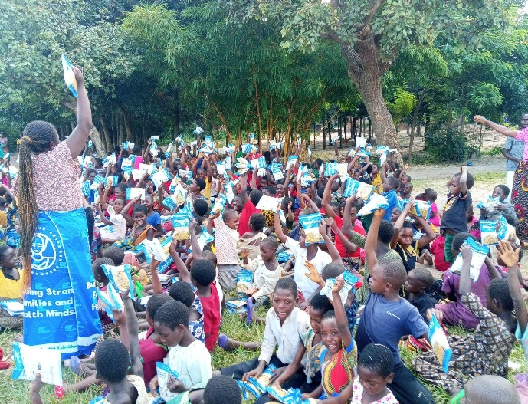
Nutritional support (Mana pack) has been contributing factor of advocacy and Systems Strengthening on ACE programs. Children Corner activities in T/A Kalolo has become a voice of hope for children who had endured pain and neglect for far too long. During distribution of supplementary Mana pack foods at Madika Children’s Corner and other learning spaces, vulnerable children were also taught about their rights, protection and the courage to speak out against forms of abuse. For many children, this was their first time they realized that being denied school, forced into child labour, beaten at home as well as experiencing exploitation was not normal. In 2026 alone, 25 child protection cases were bravely reported by the children themselves to Child Protection Worker (CPWs), Case workers and other relevant local stakeholders in the field of child protection. This has also facilitated urgent intervention by ACE Organization, community stakeholders, government officers (CPWs), Police, and local leaders as well. As a result, ACE has facilitated to 20 (8 boys 12 girls) children who had lost hope of ever returning to school been now back in the classroom. “I didn’t hope that one day I will be back to school lamented Febby Francis, one of the girls at Madika CC.” Their families also received PSS and guidance to create safer homes. Today, the smiles of children walking back to school and knowing they have food at home stands as a powerful testimony that when children are empowered with nutritious food, they raise their voices to achieve their dreams and restore their futures.

Brief summary of the impact in the stories above:
On behalf of all the beneficiaries of this kind of supplementary nutritious food of Manapack, Alliance for Children Everywhere (ACE) extends the deepest and most heartfelt gratitude to the donor for the generous support. Your kindness and compassion have touched the lives of vulnerable children and families in Malawi and also in a truly meaningful way. On our happiness, we cannot find enough words to describe our feelings. However, your contribution is not just food to these children and their communities; it has been a symbol of love, care and humanity. The impact of your generosity will continue to be remembered in the smiles of the children, the gratitude of parents and the strengthened spirit of the communities you have supported.
May you be sincerely appreciated and blessed for making a lasting difference in the lives of those in need.

